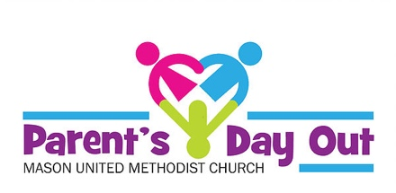
6315 S. Mason Montgomery Road
Mason, OH. 45040
(513) 398-4741 tharris@masonumc.org

Physical Form
2019/2020

A child will not be admitted to the Parent’s Day Out Program without this completed form, which is valid for one year from date of physician signature.

This is to certify that________________________________________________
(Child’s name)
- Has received a physical examination. Date of examination ____________
- Is free from communicable disease and is in suitable condition for participation in a group care.
- Has had age appropriate immunizations recommended by the Ohio Department of Health:
Diphtheria, Tetanus, Pertussis (D TaP) __________________
Hepatitis B (Hep B) _____________________
Haemophilus Influenza type b (HIB) ____________________
Measles, Mumps, Rubella (MMR) ____________________
Inactivated Polio ______________________
Varicella __________________________
Influenza ____________________________
Pneumococcal Conjugate (PCV) _______________________
Rotavirus _________________________
Hepatitis A ______________________
Other________________________

Physician’s signature____________________________________________
(Licensed physician signature only)

Physician’s address ___________________________________________________

