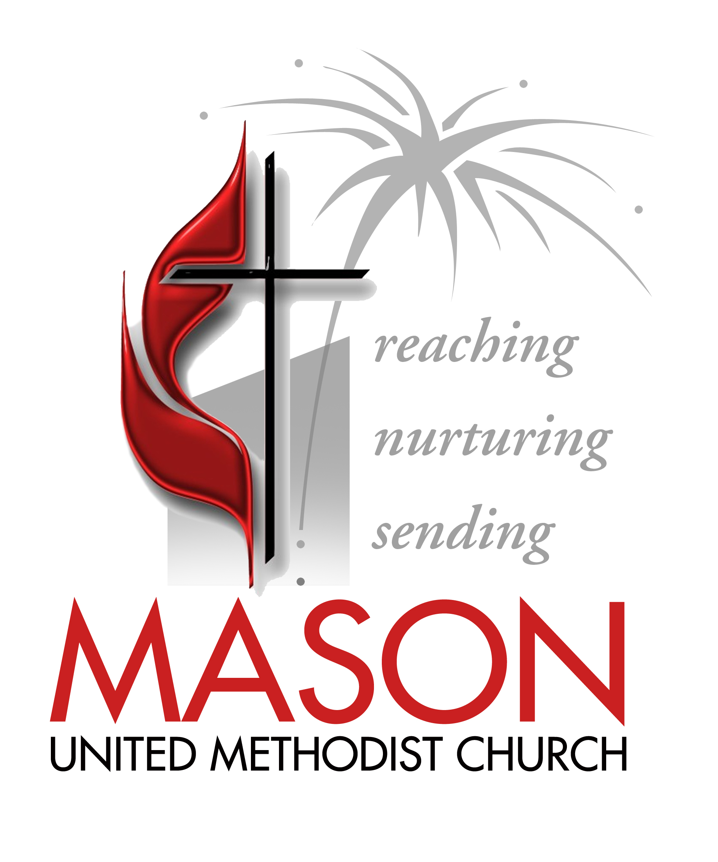
Leadership Covenant
MASON UNITED METHODIST CHURCH

We believe the church belongs to God and that the church is, in the words of the Apostle Paul, the body of Christ. The church is to be the physical presence of Christ in the world. We believe that God has called Mason United Methodist Church for the following:

Our Vision
To be a reaching, nurturing, sending community of committed followers of Jesus.

Our Purpose
Equipping disciples to live God’s mission to renew the face of the earth.

Our Expectations of all Members
1. To attend worship unless ill or out of town.
2. To grow in your faith outside of worship in prayer and Bible study or small group
3. To give proportionate to your income with a tithe being the goal.
4. To serve in ministry, according to your gifts.

Our Expectations of Leaders
1. To have an ability to motivate others.
2. To have a willingness to listen.
3. To understand and know the mission and vision of the church.
4. To be someone with a strong Christian faith.
5. To be active in the church community.
6. To have commitment and passion.
7. To be able to work with others.
8. To be a creative “out of the box” thinker.
9. To be able to follow through with a plan.
10. To commit to attend training events.
Living the Leader Covenant
Mason United Methodist Church

Our lay leaders, along with our staff, fulfill the biblical roles of elders and deacons, shepherds and teachers. Throughout the New Testament, leaders are called to be examples to the rest of the church. Paul sets forth lists of attributes of elders and deacons in his letters to the early church. Peter, likewise, challenges leaders to be “examples to the flock” and to exercise leadership with a willing heart.

As leaders, we set the tone and pace for the entire congregation. We model the Christian faith, the Christian life, and the attitude and heart of a Christian for our congregation. We shape the heart, character and life of this Christian community. For this reason, it is vital that we walk the Christian journey always growing in our relationship with God. Spiritually healthy leaders will produce a spiritually healthy church.

With this in mind, the following covenant was developed to guide our life together as leaders.

I. The Goal of the Christian Life.
Jesus summarized the goal of the Christian life with two commandments: love the Lord your God with all your heart, soul, mind and strength; and love your neighbor as yourself. John Wesley spoke of this goal as sanctification, Christian perfection, or holiness. In our Methodist tradition, three General Rules were designed to help Christians pursue this goal.
They are:
A. Do no harm.
B. Do good.
C. Stay in love with God.
We may think of these like the following:
1. Live a life of love.
2. Share your faith.
3. Build others up.
4. Be engaged with those in need.
5. Attend worship.
6. Engage in Christian friendships for spiritual growth and accountability.
7. Serve God with your time and talents.
8. Spend time in prayer and the personal study of scripture.

II. The Heart and Attitude of a Leader at Mason United Methodist Church
A. What does the heart and attitude of a MUMC leader aspire to?
1. Commitment to Christ
2. Devotion to the purpose and vision of Mason UMC
3. Humility (servant hood)
4. Positiveness
5. Joyfulness
B. How will MUMC leaders strive to live toward one another?
1. Demonstrate respect and grace.
2. Accept differences.
3. Maintain appropriate confidentiality.
4. Publicly support other servant leaders, pastors and staff members.
5. Go directly to the individual whenever a problem arises.

III. The Faith and Character of a United Methodist¹
Mason is a United Methodist Church. We expect our leaders to honor our denominational heritage and to pursue ministry in keeping with our tradition.

United Methodists are people who seek to love and serve God with our head, our heart and our hands. We:

  - are passionate and deeply devoted to Jesus Christ, and desire to be wholly surrendered to God.
  - bring together both the evangelical and social gospel – inviting people to a life-transforming relationship with Jesus Christ, and then equipping and challenging them to live their faith in the public sphere, being engaged in the issues of our time and seeking to shape a world that looks more like the Kingdom of God.
  - have been known as “reasonable enthusiasts” – valuing both a personal, passionate faith and one that is intellectually informed.
  - are constantly looking to connect our faith to the world in meaningful, relevant ways. Methodists value spiritual disciplines and a “methodical” approach to growing in the faith.
  - strive for both personal holiness and social holiness.
  - are not afraid to ask difficult questions, to take on tough subjects, and to admit that they do not always understand the answers.
  - are “people of the Book” - holding the Bible to be the inspired Word from God and encouraging people to read, to study and to live by its words. “While we acknowledge the primacy of Scripture in theological reflection, our attempts to grasp its meaning always involve experience, tradition and reason. Like Scripture, these become creative vehicles of the Holy Spirit as they function within the church.”
  - also believe the Bible came to us through people who heard God’s Word in the light of their own cultural and historical circumstances.
  - study the scriptures carefully, making use of scholarship and asking critical questions.
  - may encounter theological differences amongst Christians, so we bear in mind John Wesley’s approach, “in essentials, unity; in nonessentials, liberty; in all things, charity.”
  - are people who love God with all their heart, soul, mind and strength, and love their neighbors.
  - pursue acts of piety toward God and acts of mercy toward others.
  - value passionate worship, relevant preaching, small groups to hold Christians accountable to one another, the need to address the social issues of our time, and the need to be people whose faith is firmly rooted in and built upon the scriptures.
  - value the full participation of women and men, people of all races, classes and backgrounds in all facets of fellowship and leadership within the church and society.

This is our heritage, and it continues to shape Mason United Methodist Church in every area of our ministry.

Covenant:
I have read the above and am committed to living my life and pursuing ministry in a way that is consistent with these goals, and at the Mason United Methodist Church.

___________________________________________ _______________________
Name Date

1 2004 Book of Discipline of the United Methodist Church, ¶ 104. 2 ¶ 102.
Revised: Oct. 2005

