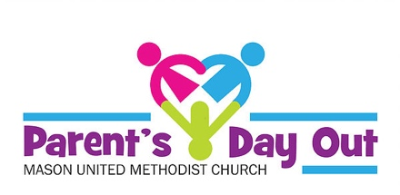
Office Use Only
Check #_____________

Amt. $______________

Date_______________

6315 S. Mason Montgomery Road
Mason, OH. 45040
(513) 398-4741 eschmidt@masonumc.org

Registration Contract

Register the following child(ren) for Parent’s Day Out at Mason United Methodist Church for the 2019/2020 program. I understand and agree that a 30-day written notice is required for leaving the program in order to avoid paying the next months fees and that the registration fee is non-refundable.

Registration fee is $50.00 per child or $75.00 per family make checks payable to: PDO@MUMC

Child(ren) Name(s)____________________________ Birth Date_____________ Gender_____

____________________________ Birth Date_____________ Gender_____

____________________________ Birth Date_____________ Gender_____

Mother’s Name_________________________ Father’s Name__________________________

Child lives with: _____Mother/Father ____Mother ____Father ____Guardian ____Other

Phone Number______________________ Email Address_____________________________

Address______________________________________________________________________

City_________________________________ Zip_____________________________________

Church currently attending (if applicable)__________________________________________

PDO is currently being offered on Wednesdays only.

How did you hear about Parent’s Day Out?_________________________________________

Signature of Parent or Guardian____________________________ Date________________

